Photo by [Saeed Siddiqui](https://unsplash.com/@saeedsid?utm_source=unsplash&utm_medium=referral&utm_content=creditCopyText) on [Unsplash](https://unsplash.com/@saeedsid?utm_source=unsplash&utm_medium=referral&utm_content=creditCopyText)

# The legacy of the land

**Biodiversity in the Mediterranean agricultural landscapes**

Cereals, vegetables, citrus fruits, olive orchards and vines. The fertile grounds of the Mediterranean have been harvested for centuries, feeding civilisations, shaping landscapes, cultures and societies. With their practices, farmers, shepherds and fishermen have built agricultural wisdom across generations, influencing the unique biodiversity of the Mediterranean region.

Today, the Mediterranean is under intense pressure from a variety of human activities and has become a priority for conservation. Mediterranean biodiversity is being lost at an unprecedented rate, and one of the primary drivers of this decline, particularly in terrestrial environments, is known to be agriculture[1]. However, could agriculture also be part of the solution?

# An inextricable bond

“Biodiversity is the basis of agriculture”

UN Convention on Biological Diversity[2]

If biodiversity thrives, so does agriculture: Biodiversity generates multiple ecosystem services - the direct and indirect benefits that people obtain from ecosystems - of which agriculture, as many other fields, is reliant upon. **Biodiversity is the source** of all crops and domesticated livestock, as well as, the varieties within them.

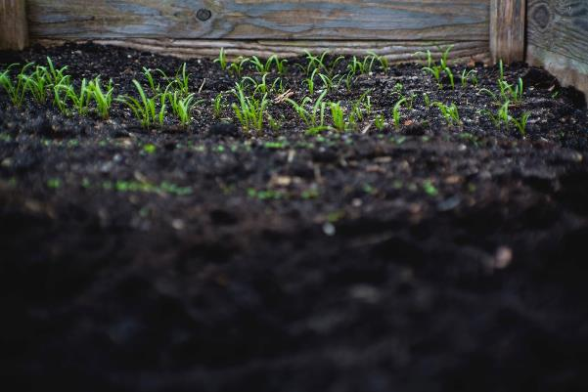

Soil biodiversity is also essential for farming systems.[3] Photo by [Markus Spiske](https://unsplash.com/@markusspiske?utm_source=unsplash&utm_medium=referral&utm_content=creditCopyText) on [Unsplash](https://unsplash.com/s/photos/soil?utm_source=unsplash&utm_medium=referral&utm_content=creditCopyText)

From vertebrates to microorganisms, agricultural landscapes hold a tremendous range of species that have a profound and positive impact on Earth’s habitability.[4] Henceforth, sustainable and well-managed agriculture systems can actually play a key role in improving biodiversity conservation. We can see many examples of the potential of these practices today.

The agricultural landscapes of the Med are the legacy of thousands of years of farming, shepherding and fishing experience. This experience and knowledge has been continuously cultivated by the Mediterranean people who developed a myriad of species and crops for human consumption through adapting their practices to local environments, traditions and customs. These **traditional practices** have proved to achieve a balanced, sustainable productivity in harmony with nature, preserving species, ecosystems and genetic diversity.

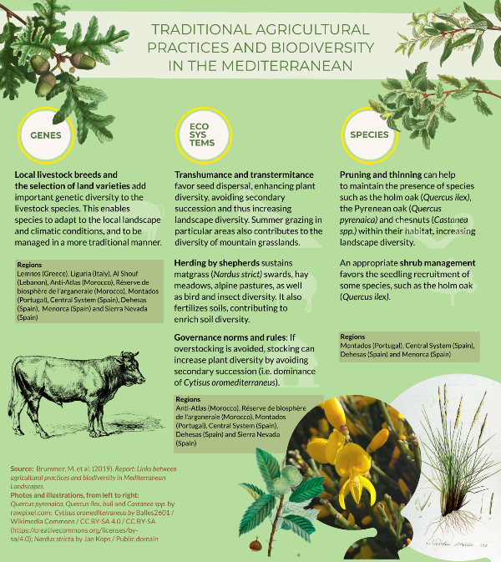

It is worth mentioning, that in the Mediterranean there are also countless cultural and sustainable practices with **structural elements** such as field margins, hedgerows, stonewalls, patches of woodland or scrub and small rivers which enhance biodiversity. However, the relationships between biodiversity, practice, and structural elements still needs to be further explored and documented.

# Curiosities

# The threat and the opportunity

Nowadays, agricultural landscapes are evolving in two opposite directions: abandonment or intensification. Traditional farming practices are giving way to a more profitable, intensive agriculture, which is provoking the loss of biodiversity which previously thrived in these landscapes.

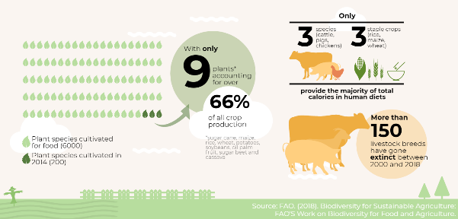

Some facts and figures regarding the loss of genetic diversity and the decline of species related to agriculture nowadays. Infographic: IUCN. Source: FAO (2018)[5]

In the Mediterranean basin, as in many other parts of the world, the **lack of crop diversity** is quite concerning: over 85 % of the total agricultural production focuses only on cereals, vegetables, and citrus fruits[6]. As the following map shows, olive orchards and vines are also important crops.

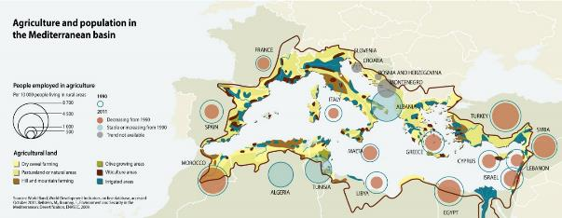

Source: [GRID-Arendal](https://www.grida.no/resources/5906).

All in all, the current trends are reducing the resilience of agricultural systems to adapt to variations, causing **instability**. In addition, they are threatening numerous wild species of plants and animals that depend on agrosilvopastoral practices in different ways, in an often complex and multidirectional relation.

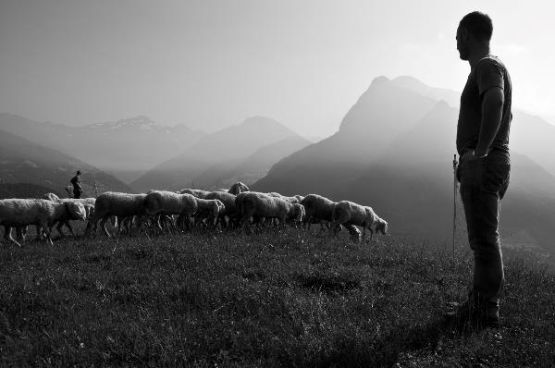

Transhumance, a practice of moving livestock from one grazing ground to another in a seasonal cycle, typically to lowlands in winter and highlands in summer. Considered a form of pastoralism, this traditional practice, currently threatened, brings many benefits to agricultural landscapes[7]. Photo by [Alberto Bigoni](https://unsplash.com/@albertobigoni?utm_source=unsplash&utm_medium=referral&utm_content=creditCopyText) on [Unsplash](https://unsplash.com/@albertobigoni?utm_source=unsplash&utm_medium=referral&utm_content=creditCopyText)

# A pledge for a more holistic approach

The benefits and values that healthy ecosystems and biodiversity provide are countless. This bond is particularly present in agricultural landscapes, but not always apparent. Agricultural productivity is typically measured by yield per hectare, a simplistic metric that does not account for the costs to our health, livelihoods, soils, water and climate[8]. According to the [UN Convention on Biological Diversity](https://www.cbd.int/undb/media/factsheets/undb-factsheet-ecoserv-en.pdf), “the precise link between diversity and the capacity of an ecosystem to provide services is a complex one, and an area in which science is still developing.” Some initiatives, like The Economics of Ecosystems and Biodiversity for Agriculture and Food ([TEEBAgriFood](http://teebweb.org/agrifood/)), are focusing on **making these** **benefits more visible** and demonstrating their value in economic terms.

With 10 billion people to feed by 2050 and 40 percent of available land already growing food[9], new frameworks and models are very much needed to **rethink the way food arrives** on our plates. Sustainable, traditional agricultural practices may contribute to shine a light on the positive linkages of food systems to the environment and society.

When managed sustainably and knowledgeably, biodiversity provides the necessary resources for agriculture to thrive while having a minimal negative impact on the environment[10]. Many **traditional practices** have proved to be sustainable benefiting biodiversity at a large, and the Mediterranean basin offers many examples of it. Unfortunately, this invaluable heritage is being lost for different social and economic reasons, often influenced by lower productivity and profitability. To stop the loss of these practices, it is decisive to **recognize the benefits they provide,** and develop mechanisms to enhance them.

# Map

<https://www.google.com/maps/d/u/0/viewer?ll=38.15885668246305%2C13.305090000000064&z=5&mid=1s4v3S0-uTPlNbGUof4WZTCdoqhE9W-ax>

This map includes a compilation of different scientific papers documenting agricultural practices in the Mediterranean region that benefit different species of fauna and flora at three different levels: plot, farm and landscape. It is important to highlight that applying one specific practice is not enough to increase the associated biodiversity, as the agroecosystems are complex and interlinked in many different ways.

*Plot level:* Practices affecting mostly species with low mobility. Here, maintaining ground cover has proven to benefit biodiversity.

*Farm level:* Practices that include structural elements, like stonewalls, dead standing trees, solitary trees or field margins. Some of the practices at farm level benefit some species but harm others.

*Landscape level:* Some species of birds or bats only benefit from heterogeneous landscapes, as these articles describe.

*Special sites:* Places where many practices are being performed simultaneously or are working to better understand the link between practices and biodiversity.

# Taking action

“Good governance, enabling frameworks, and stewardship incentives are needed to facilitate mainstreaming of biodiversity.”

The Food and Agriculture Organisation of the United Nations (FAO)[11]

The Food and Agriculture Organisation of the United Nations (FAO) has also been very active mainstreaming biodiversity across sectors of agriculture: launching a [**Biodiversity Mainstreaming Platform**](http://www.fao.org/biodiversity/mainstreaming-platform/en/), spreading awareness and mobilizing resources. The recent [FAO strategy on mainstreaming biodiversity](http://www.fao.org/3/ca7722en/ca7722en.pdf), approved in 2019, is the result of several regional dialogues with key stakeholders, and constitutes a significant effort to gather key knowledge to catalyse actions on this subject.

The Centre for Mediterranean Cooperation of the International Union for the Conservation of Nature (IUCN-Med) is in the process of developing a new strategic line of work, which will aim to enable **positive feedbacks** between agriculture and biodiversity, and to ensure that practitioners receive sufficient **socio-economic support** to maintain the positive practices for biodiversity.

The MAVA Foundation - a major funding partner of conservation projects - has created a programme to promote “**cultural practices that shape the cultural landscapes which in turn, harbour biodiversity and preserve natural capital**” in the Mediterranean Basin. IUCN-Med participates in this programme with several partners, developing actions that will improve the knowledge and monitoring of biodiversity. Activities are held mainly in five pilot landscapes: the Moroccan High Atlas, the Island of Lemnos in Greece, agricultural terraces in the Lebanese Al-Shouf Cedar Nature Reserve, grazing pastures of Portugal (Montados) and Spain (Dehesas), and the island of Menorca in Spain. This programme will also provide more examples of agricultural practices benefiting biodiversity across the Mediterranean region.

## LOGOS of all the partners of the project

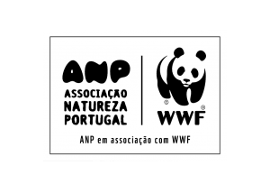

## Do you want to learn more?

[M6 MAVA-Promoting sustainable land use practices](http://mava-foundation.org/oaps/promoting-sustainable-land-use-practices-2/)

[Fact sheet and report WE&B](https://www.iucn.org/sites/dev/files/content/documents/facsheet_iucn_v3.pdf)

[Rooted everyday](https://www.rootedeveryday.org/)

[Biodiversity Knowledge and Monitoring-IUCN Med](https://www.iucn.org/regions/mediterranean/projects/current-projects/knowledge-and-monitoring-biodiversity-0)

[UNESCO Cultural landscapes](https://whc.unesco.org/en/culturallandscape/)

[FAO Globally Important Agricultural Heritage Systems (GIAHS)](http://www.fao.org/giahs/en/)

[FAO Biodiversity Mainstreaming Platform](http://www.fao.org/biodiversity/mainstreaming-platform/en/)

[FAO strategy on mainstreaming biodiversity](http://www.fao.org/3/ca7722en/ca7722en.pdf)

## References

1. IUCN Centre for Mediterranean Cooperation. [The Mediterranean, a global priority for conservation](https://www.iucn.org/sites/dev/files/content/documents/infografia_uicn_med_a3_nov29.pdf). Infographic, November 2018.
2. Secretariat of the Convention on Biological Diversity (2008). [Biodiversity and Agriculture: Safeguarding Biodiversity and Securing Food for the World](http://www.fao.org/fileadmin/templates/soilbiodiversity/Downloadable_files/P020080603430792943555.pdf). Montreal, 56 pages
3. <https://www.globalsoilbiodiversity.org/>
4. Ed. Hamilton S, Doll J & Robertson G. “The ecology of agricultural landscapes: long term research on the path to sustainability” 2015, Oxford University press.
5. FAO (2018). [Biodiversity for Sustainable Agriculture: FAO’s Work on Biodiversity for Food and Agriculture](http://www.fao.org/3/CA2227EN/ca2227en.pdf).
6. [UNEP/MAP-Plan Bleu: State of the Environment and Development in the Mediterranean](https://wedocs.unep.org/bitstream/handle/20.500.11822/386/soed2009_eng.pdf?sequence=3&isAllowed=y),

   UNEP/MAP-Plan Bleu, Athens, 2009
7. Aryal S., Maraseni T., Cockfield G., de Bruyn L.L. (2018) [Transhumance, Livestock Mobility and Mutual Benefits Between Crop and Livestock Production](https://link.springer.com/chapter/10.1007/978-3-319-94232-2_2). In: Lichtfouse E. (eds) Sustainable Agriculture Reviews 31. Sustainable Agriculture Reviews, vol 31. Springer, Cham
8. The Economics of Ecosystems and Biodiversity (TEEB) (2018). Measuring what matters in agriculture and food systems: a synthesis of the results and recommendations of TEEB for Agriculture and Food’s Scientific and Economic Foundations report. Geneva: UN Environment.
9. The Economics of Ecosystems and Biodiversity (TEEB) (2018). Measuring what matters in agriculture and food systems: a synthesis of the results and recommendations of TEEB for Agriculture and Food’s Scientific and Economic Foundations report. Geneva: UN Environment.
10. Biodiversity International, 2017. [*Mainstreaming Agrobiodiversity in Sustainable Food Systems: Scientific Foundations for an Agrobiodiversity Index*](https://www.bioversityinternational.org/mainstreaming-agrobiodiversity/)*.* Biodiversity International, Rome, Italy.
11. FAO (2018). [Sustainable Agriculture for Biodiversity: Biodiversity for Sustainable Agriculture](http://www.fao.org/3/a-i6602e.pdf)

    By

    Mercedes Muñoz

    &

    Cecilia Saura Drago

    for

    IUCN Centre for Mediterranean Cooperation

    with the contribution of Marcos Valderrábano, Lourdes Lázaro & Catherine Numa

    _____________________________________________________

    IUCN Centre for Mediterranean Cooperation

    C/ Marie Curie 22  
    29590 Campanillas  
    Malaga, Spain  
      
    Tél +34 352 02 84 30  
    Fax +34 352 02 84 30  
    [www.iucn.org/mediterranean](http://www.iucn.org/mediterranean)